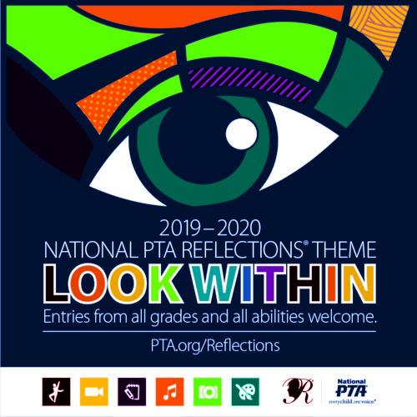
2019-2020 Reflections Theme
“LOOK WITHIN”

Reflections Program Overview for families and students

Welcome to Creekside PTSA’s art Reflections program for 2019-2020! Reflections is a National PTA arts recognition program that helps students explore their own thoughts, feelings and ideas, develop artistic literacy, increase confidence and find a love for learning that will help them become more successful not only in school, but in life. The primary focus of Reflections is a celebration of creativity through positive recognition.
Creekside students of all grades and artistic abilities are invited to create original works of art in response to this year’s theme, Look Within in any of the following arts categories: Dance Choreography, Film Production, Literature, Music Composition, Photography and Visual Arts.
Check out the National PTA’s 2020 Reflections video Click here overview! Program Details
Creekside students may submit an original entry in any of six arts areas and can submit up to 3 entries (total) in any category. Entries can be submitted starting Tuesday, October 15th through Friday, October 25th. All Creekside entries are due by Friday, October 25th in the Reflections entry bin, located outside of the Creekside office.

- Literature: Works of fiction, nonfiction, poetry, prose, drama, short stories and lyrics.
- Music Composition: Original musical composition, with or without words.
- Photography: Color or black and white, included techniques: photogram, negative sandwich, and multiple exposure.
- Visual Arts: Drawing, painting in tempera, oil, acrylic, watercolor & t-shirt paints, computer generated art, two-dimensional collage, printmaking, needlework & leather tooling.
- Film/Video: Original works, with or without sound, of animation, narrative, documentary, experimental or music video/film.
- Choreography/Dance: Originally choreographed dance composition.

Creekside will have 12 entries which will go onto the district and have potential to move on to state, then nationals.

Each student and their families who enters be invited to a Celebration art viewing and reception in November.

How to Enter (entry packets, rules & guidelines)

To enter, follow the packet, which includes official rules, guidelines for each category and the entry form. Hard copies are available on the Reflections board, located outside the Creekside office OR you can view online and print the entry form.

2019-20 Dance Choreography Packet

2019-20 Film Production Packet

2019-20 Literature Packet

2019-20 Visual Art Packet 2D & 3D

2019-20 Music Composition Packet

2019-20 Photography Packet

2019-20 Special Artist Division (for students who receive specific services, see sheet)

All entries must be original work of one student and are judged on Interpretation of Theme “Look Within”, Creativity and Technique.

Judging

Each entry is judged blindly, meaning no names are associated with the pieces of work. Judges have a background in the category they are judging.

Each entry is judged on the following (note this has changed from previous years):
- Interpretation of Theme (Look within)
- Creativity
- Technique
Entries are organized by student age and grade levels. Student works are judged in the same grade division. This allows recognition and judging of artworks by appropriate developmental age and skill levels. The grade divisions are:
- Primary: Kindergarten – Grade 2
- Intermediate: Grades 3 – 5

Volunteers Needed

Are you interested in getting involved with Reflections?
Please email Laura Hassel for opportunities to get involved. Thank you!

Questions?

If you have any questions regarding Reflections, please contact the Reflections Chair Laura Hassel.

Good luck to all participants!

Congratulations and thank you to Creekside’s 2018/2019 “Heroes Around Me” Reflections 42 participants, 12 Creekside Finalists and Issaquah District Finalist and Honorable Mention

12 Creekside Finalists
Marina Hassel, 1st grade, Visual Arts
Ellie Wang, 1st grade, Visual Arts
Luke Nguyen, 1st grade, Visual Arts
David Liao, 2nd grade, Visual Arts
Sam Crissman, 2nd grade, Film Production
Rohan Nair, 3nd grade, Visual Arts
Mihir Nair, 3nd grade, Visual Arts *Issaquah District Finalist
Erin Bian 3rd grade, Literature
Adwita Satapathy, 3rd grade, Literature
Advitha Sri, 4th grade, Visual Arts *Issaquah District Honorable Mention
Dhruti Pachalla, 5th grade, Visual Arts
Tulasipriya Chandaka, 5th grade, Visual Arts
